Dream Board Activity
Team Leader:
Purpose: This is a goal setting activity. Team members will create a dream board showing what is important to them.
Time: 20 Minutes
Materials: Poster Board/Construction Paper
Markers/ Crayons
Scissors
Glue
Magazines/Newspaper (to tear or cut out photos)

Activity Steps:
1. Choose a poster board or construction paper.

2. Search in magazines for pictures that can be used 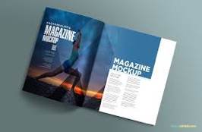
in your vision/dream.

3. Draw a picture or cut or tear picture from magazine.

4. Glue picture onto the board/construction paper.

4. Write a caption next to the picture of your dream.

5. Repeat the steps for each picture.

Copyright ©2020 Tammy Evrard Consulting. This work is licensed under a Creative Commons Attribution-NonCommercial-ShareAlike 4.0 International License.

