**

**How to Use Zoom Conference Call**

1. Dial the number that was provided in an email by the meeting host.
2. *For example:*

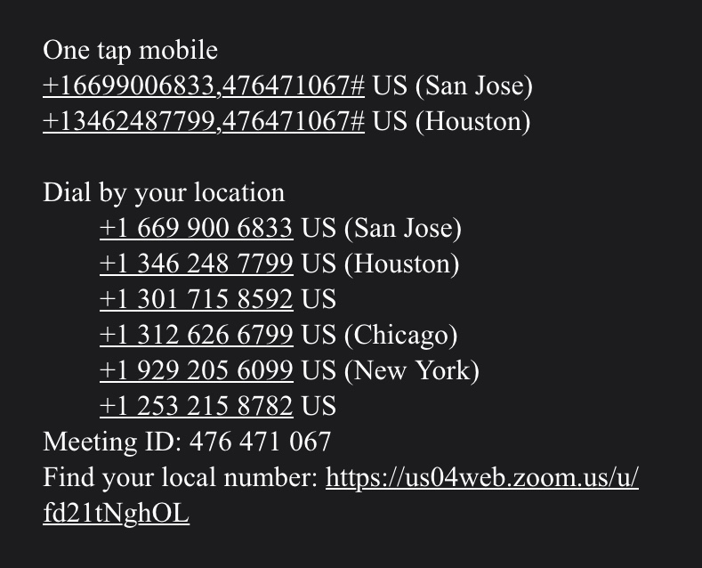

1. Once you dial the number, then it will ask for you to type in the “Meeting I.D.”
2. The “Meeting I.D.” can be found in an email sent by the host.

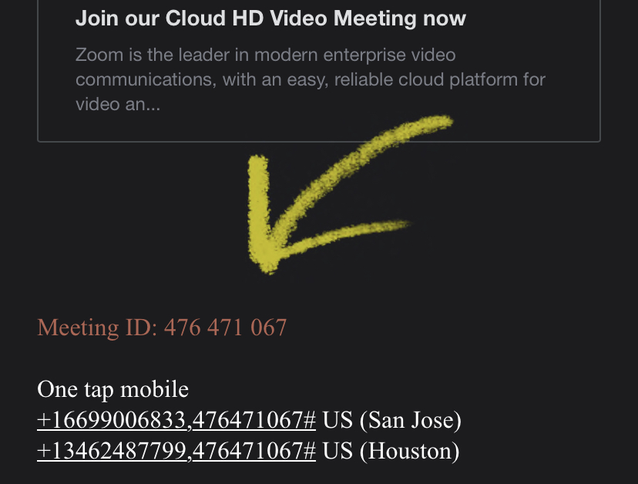

1. After dialing the meeting I.D., press “#” to join as a participant.
2. The meeting will start once the host arrives.

