

**How to Use Zoom**

1. Open “Zoom” on computer or phone.
2. If you are using a phone, then download the Zoom app.

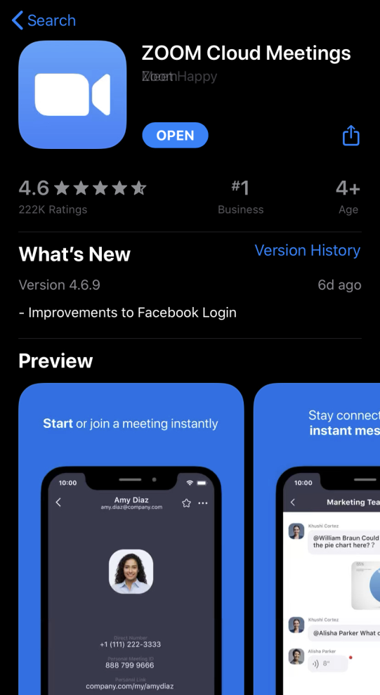

1. To join a meeting, type in the Meeting I.D. number, OR press on the web link that was sent to you through email.

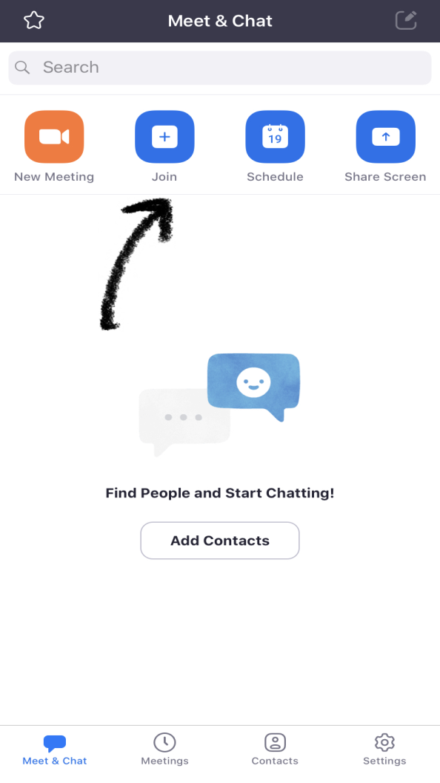

1. Please add the password that was included in the email. Without the password you will not be able to join the meeting.

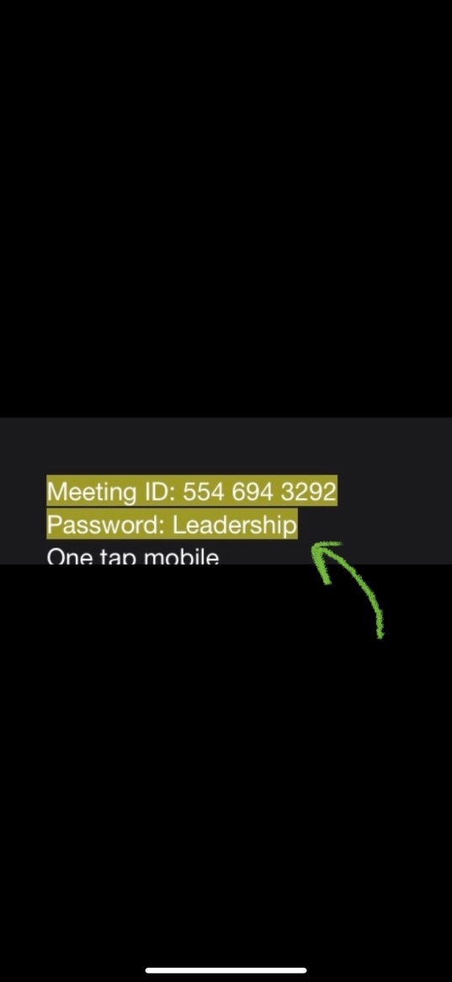

1. Once you enter the meeting I.D., or press the web link then you will start the meeting.

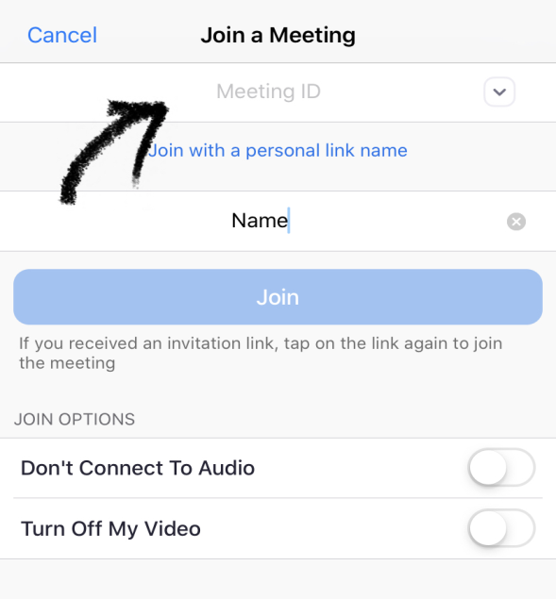

1. Reminder, please make sure your microphone is turned on.

