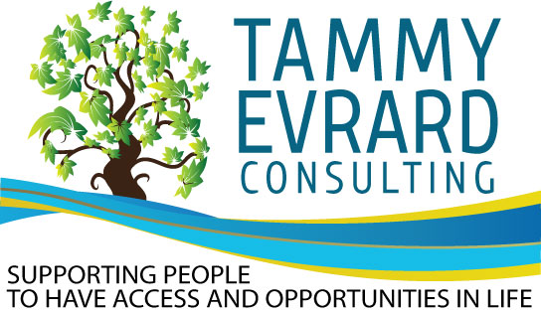
May 2020 Newsletter

Staying Healthy and Safe: Staying Connected

In March, I began to receive calls from self-advocates some I haven’t heard from in over a year. A strange coincidence? No. The coronavirus was here and now life had changed. At first, I was worried for each of them. How did they feel about what was happening? Did they have the help they needed? Did they have toilet paper, food, and other essentials.

Then I realized, in a time of crisis, they called me. Now, I’m not saying I’m the only one on speed dial on their phone, but I was amazed I was still someone they felt they could call. We were connected by our life experiences. We had trust. We had friendship.

In the beginning the calls were several times a day from each person, then we began our Empowerment Calls. A weekly conference call on Zoom for people to stay connected and take charge of their emotions, meet new people, focus on meaningful activities. An inclusive open forum for self-advocates, families, providers and agencies.

The direct calls to me dropped to 1–2 a day. Everyone was focused on their assignments — their next call — talking to a new friend. Everyone learned Zoom. People were home and connected to their families who helped them complete tasks and attend the meetings.

The power of staying connected is so important. The need to talk to someone and be heard. The need to laugh, to share your worries, to be focused in living life now is so vital. Even in my own family, my relationship with my husband, daughter, and parents strengthened as we spent day after day together —happy to stop and just appreciate the love and presence of family.

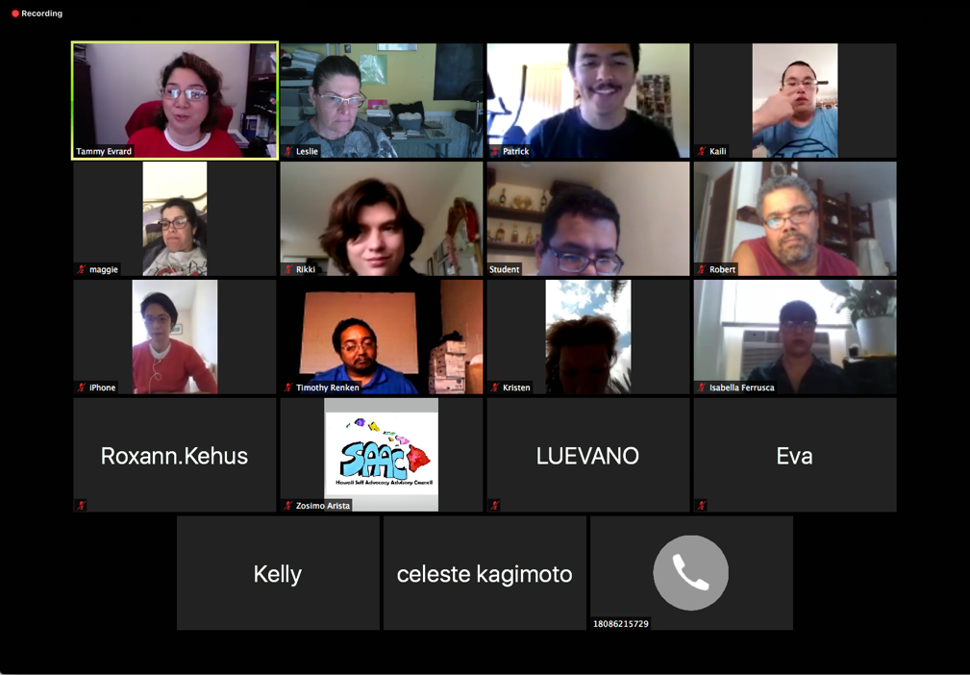

I am honored to be of social value to those who call me friend, colleague, Ohana, trusted person.

Thank you — Amanda, Amy, Bathey, Caroline, Carlos, Cecelia, Celeste, Christian, Claudio, Donald, Donnally, Elizabeth, Eri, Evan, Frankie, George, Gilbert, Glenn, Herman, Ikaika, Isabella, Jack, Jesse, Joceyln, Jose, Kaili, Kammy, Katherine, Kristian, Leslie, Lisa, Maggie, Michelle M., Michelle M., Niki, Olaf, Renee, Rikki, Robert, Roger, Roxann, Shauna, Shawntris, Soledad, Susan, Tia, Tonya, Travis, Timothy, Zosimo.

I look forward to our next call and seeing all of you on Tuesday…

Mahalo,
Tammy Evrard

Michelle Manfredi — Parents Perspective

Covid-19 has created some interesting opportunities to stay connected. I think it has opened doors that were closed. Doors I believe and hope will stay open. A new roadway has been suddenly built because agencies, businesses, non-profits, doctors all need to reach out to their clients and to their community partners. Tools that were used for a few meetings, are now the ONLY way to continue business and to continue business means we have to stay connected.

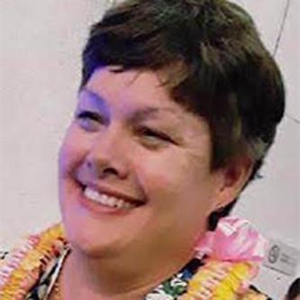
During this time, Renee and I have been very connected, maybe even more than before because advocates are being reached where they are at: their homes. Distance and transportation are not the barriers they usually are for people. All people. You can join a meeting from your home, your car, your bedroom, the kitchen, anywhere. Renee and I have been on virtual calls for our usual monthly meetings with the SO Board of Directors, Developmental Disability Councils, Tammy Evrard Consulting, Live Zoom Exercise Challenges, Video messages via Zoom, Microsoft Teams, and GoToMeeting. As well as new meetings with the purpose of connecting athletes and advocates during this time where programs are put on pause, such as exercise challenges and weekly exercise submissions through social media outlets with Special Olympics.

What I like is it is a level playing field. EVERYONE is having to learn new skills, new ways. The struggle is pretty even.

Parents, CEOs, teachers, advocates, Drs, administrators, Churches, Special Olympics, Adult Day Programs, are ALL thinking out of the box to reach people. So it’s not just me or Renee trying to learn new ways, it is everyone, and when it’s everyone, there is a lot of forgiveness when it doesn’t go just right. “Your mic isn’t muted,” “the video is still on,” your child runs through your meeting. These mistakes are happening to everyone all over the world. Everyone is being patient and kind while we all learn a new normal.

I hope we remember that patience when Normal returns. I hope we remember we CAN reach people where they are at. I hope we continue to try to #StayConnected.
THOUGHTS FROM THE IMPACT TRAINERS
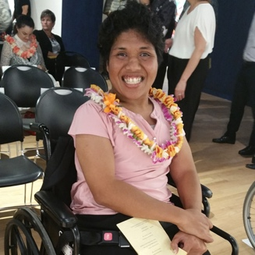
Who do you talk to when you are feeling worried, or sad?
I talk to my foster mom when I am feeling scared because she knows how to calm me down. I talk and face time with my friend in California when I am feeling sad. She makes me laugh with her jokes. I have been teaching her my Samoan language, and she teaches me Vietnamese.
– Bathey Fong

When I get scared, or sad, I talk to my mom or dad because they support me and make me feel better.
–Patrick McGoldrick
What have you learned about communication during this time at home?
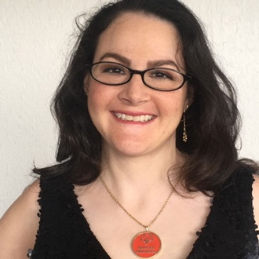
Since our stay at home order, I have learned the importance of Zoom. I am enjoying Zoom because we are together even though we are far away. It’s a great way to see my friends and still be able to engage in activities with them. It makes me think that even after our Stay at Home, I hope we can still Zoom to see each other. Because this allows us to be together in spite of transportation issues, distance, or COVID-19.
–Renee Manfredi
How do you prefer to communicate?
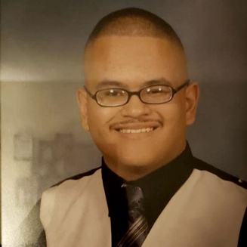
I prefer to communicate with someone on video chat because I can see and hear what is being explained to me.
–Frankie Munguia

How does communicating with friends, or family, make you feel?
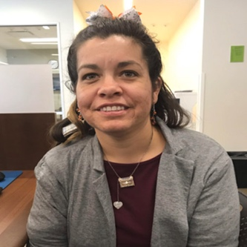
It makes me feel happy when I talk to my boyfriend Rod, friends, and family.
–Maggie Dobiesz

How have you improved your communication skills?
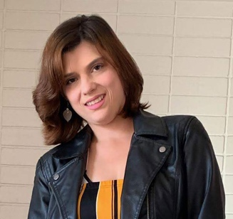
I have improved my communication skills by speaking more clearly. I rather communicate over text and video calls.
–Rikki Mansell
We are all finding new and creative ways, to stay connected during this time. Some of us have learned to video chat, and others are sending post cards. It is important to keep in touch with our friends and family, so we do not become lonely. Talking with a friend, or family member, will make us feel better if we are scared, or worried. We may feel alone sometimes but staying connected with others is important to our mind, body and soul.
–Isabella Ferrusca
