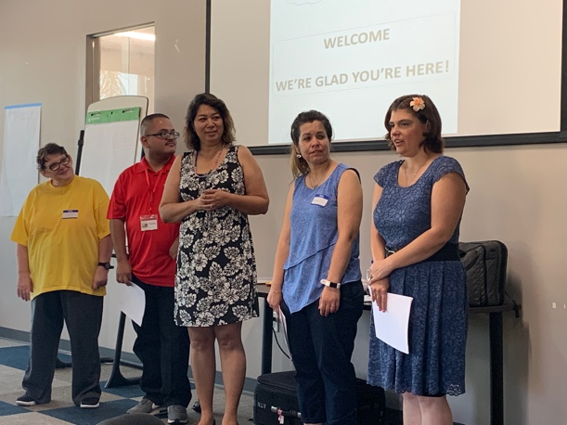

**Rikki**

Hi my name is Rikki Mansell. I am 28 years   
old. I would like to share with you what   
my New Year’s Resolution is. I want to be   
in independent living. The reason is I have   
been living in a group home for 6 years and   
it’s about to go on 7 years on April 1st. I feel I am ready and my team has brought it up and also feel like I am ready to be in independent living. I am very responsible. I am also very independent. It did not just happen right away, it took a couple of years. It was a working process to get to talk about me being ready for independent living.



**Frankie**

This newsletter is about my New Year’s resolution. My goal for 2020 is to participate in more trainings on my own because I believe I’m ready to try to conduct my own trainings. I feel that I use my voice more to talk to people and I’m not nervous like I was when I first started.

**MAGGIE**

In 2020 I plan to continue being in plays at Stagelight Productions and SLF (Stage Lights Forever Productions). I would like to try out for a role as a dancer in a play moving toward my goal as a choreographer.

**February 2020 Newsletter**

