

**Be Aloha. Stay Connected.**

COVID-19 has changed the way we do things, but it doesn’t change our spirit of helping others. It’s time for us to learn new ways to stay connected to our family, friends and community.

* + **CALL** a friend or family member and let them know you care.
  + **DONATE** food and supplies to neighbors you know need help.
  + **BUY** food and items from stores you know are working hard to stay in business. **SEND** a thank you to our first responders, medical community and workers who are trying to keep us safe and healthy.
  + **THINK** positive and smile at your neighbor and say Aloha.
  + **MAKE** a video or take a picture and post on social media.

You can make a difference. Be creative. Be part of the change to show you have a voice and care. You can contribute to others and stay connected in new and positive ways.



**March 2020 Newsletter**

**Maggie**

“I am working from home with my job coach to stay safe during the virus. I also sing “Happy Birthday” two times when I wash my hands. I order all of the items I need online, instead of going to the stores. I stay 6 feet away from other people when I’m out. I am using a lot of hand sanitizer to stay safe. My volunteer site is closed, and I cannot teach my kids at church because it is closed too. I stay busy by texting my friends, and boyfriend. I play games on my iPad, and email people. I bake things for people so I can earn money, and offer to walk dogs when the weather is nice. I stay positive by praying and thinking of happy things.”

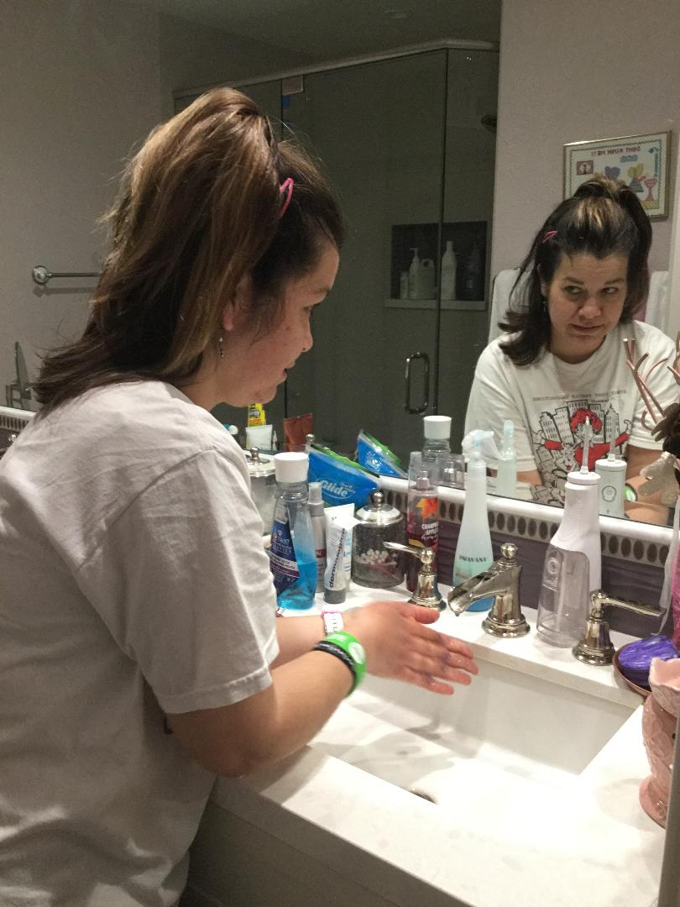

**Frankie**

“I am staying safe during this Virus by not going out, and cleaning all the places that I touch. I am also washing with soap and water to stay safe. This has really affected my program because I cannot volunteer, or work, at our internship sites. I have been staying busy by learning Powerpoint and creating a Powerpoint presentation about Epilepsy. I am staying positive and that is helping me not to worry.”

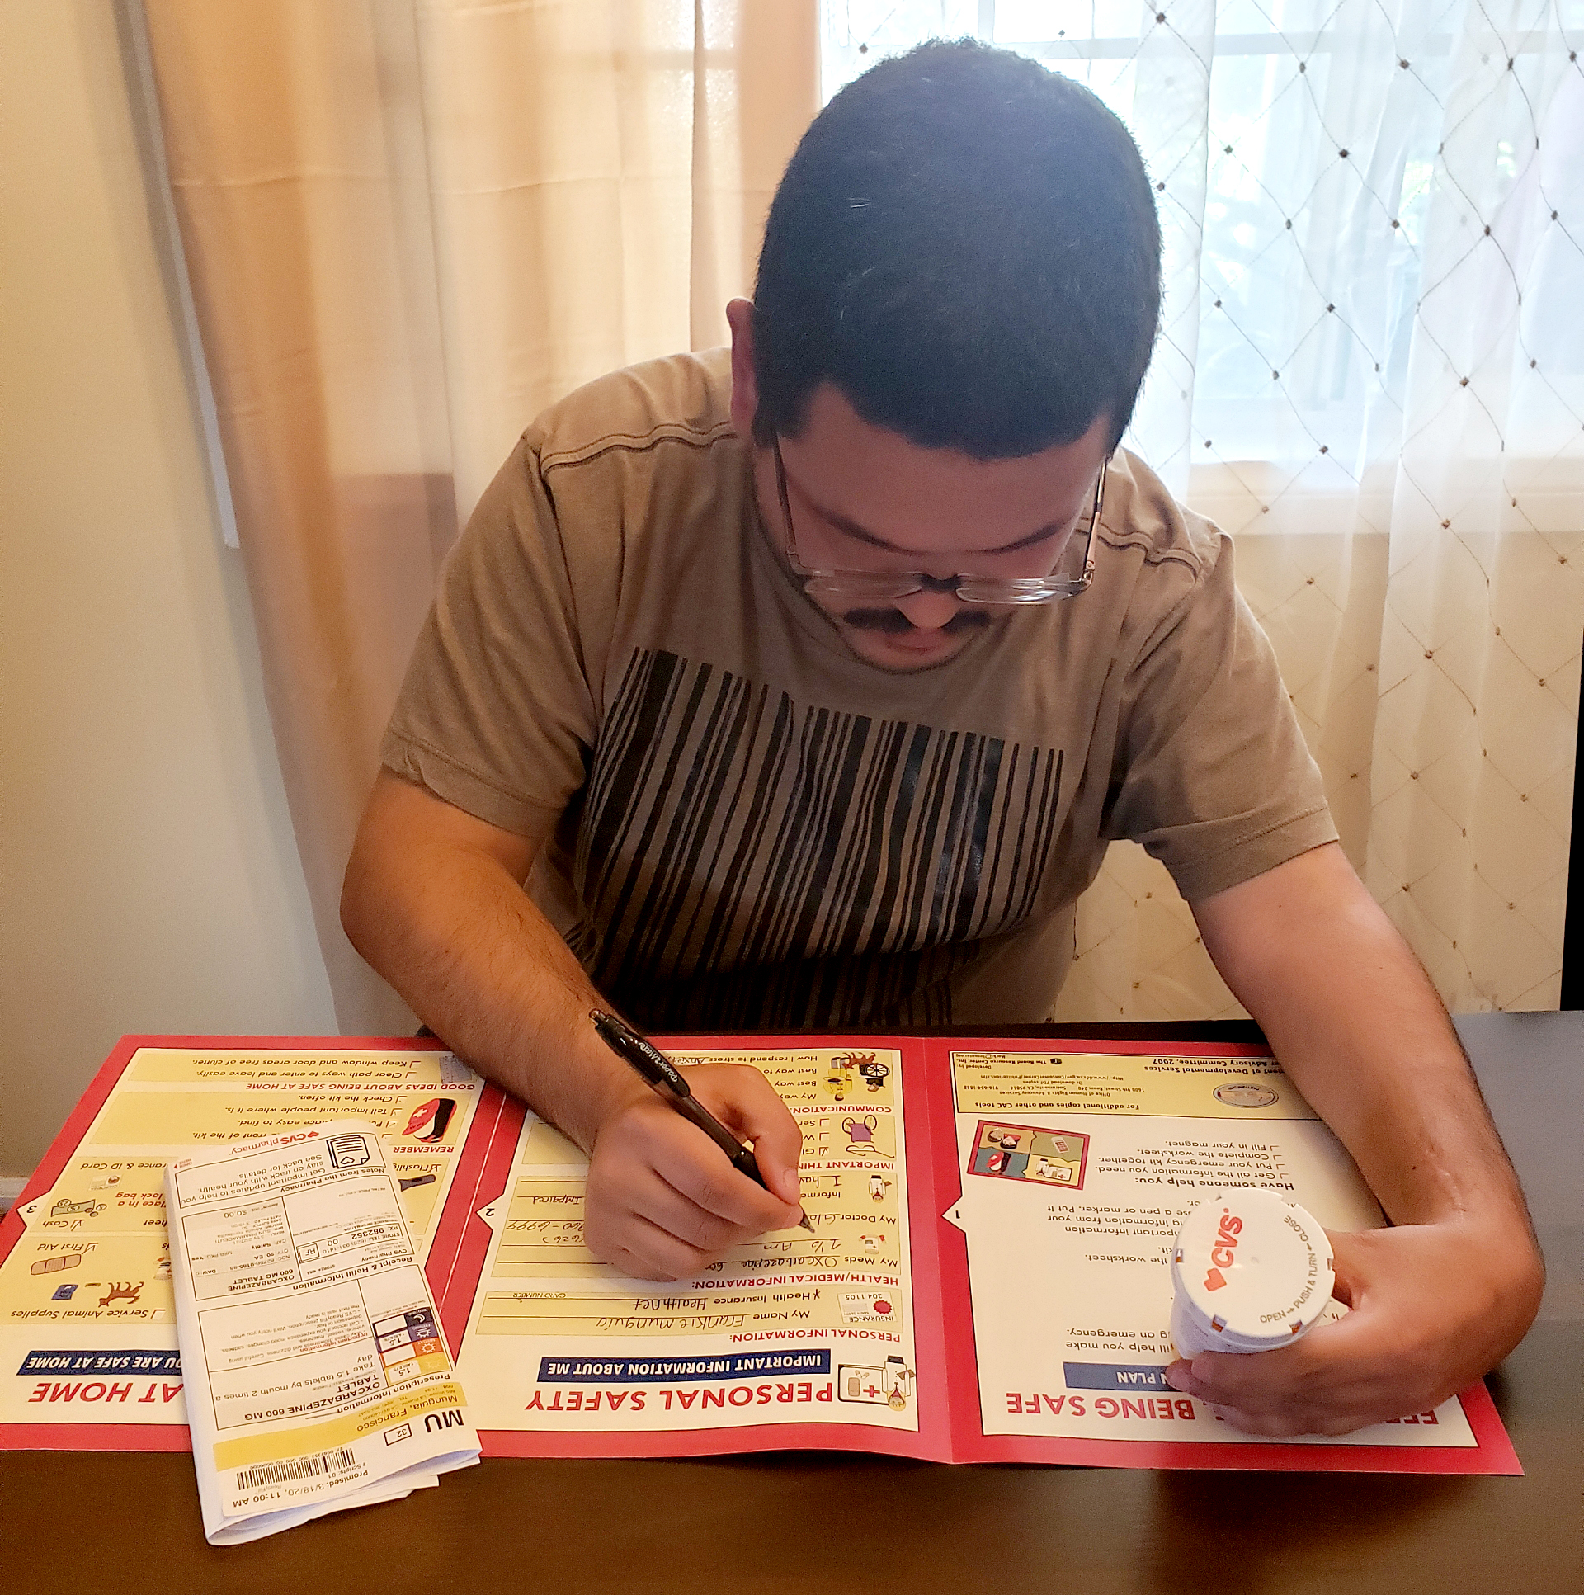

**Bathey**

“I am staying safe by staying home with my family. I am staying indoors, and watching the news to keep updated. I have been washing my hands and staying 6 feet away from others and practicing “social distancing.” I have been teaching others in my program about ways to be safe in the community by washing hands and keeping a distance from others. This virus really affected my program by stopping services temporarily. It is hard, but I have to also learn to be more understanding, and listen to what is being asked of the government. I like to go out and see my friends, but I have to listen to my family and be mindful of their recommendation to be home. I am staying busy by cleaning my room, spending time with family, social media, and checking my emails. I am grateful to be at home with family, and I am safe.”

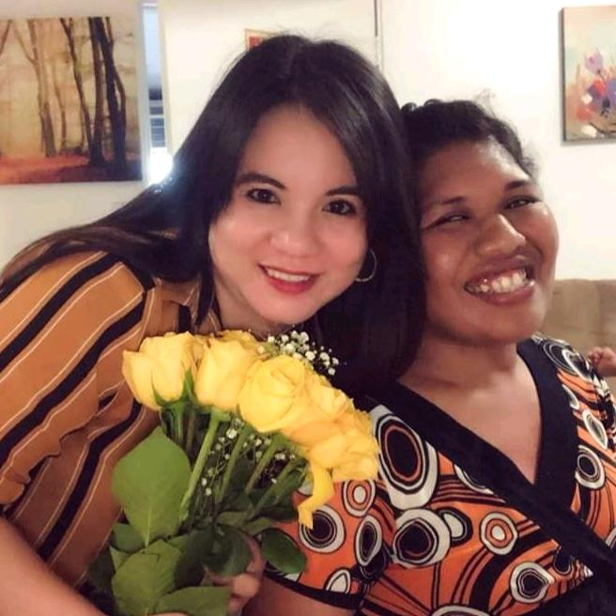

**Rikki**

“I would like to talk about the Coronavirus and how it is affecting me. I am staying safe from the virus by washing my hands so much and showering daily. I am also trying my hardest to not touch my face. I have been cleaning my room, bathroom and doing all the laundry. I am using hand soap, wipes, and lotion to be safe. My program has stopped having services, so that means I cannot go shopping, go to the library, or go to church. Also, my group at church is through video chat for now. I am keeping myself busy by doing my job duties, reading, coloring, talking to my friends and family. I am trying not to worry and keep thinking positive and not negative about the virus because if you think positive by the time you know it, it will be over. I want to know what you are doing with your time with family and the people you live with?”



**Changes in Routine **

We have all experienced a change in our routine over the last couple of weeks, and are learning new ways to communicate with friends or family, and spend more time indoors. It is important to find a new routine that will help during this time. Here are some tips that might help:

1. Have a Good Night’s Rest: Make sure not to spend too much time in bed, or you may not feel like getting up.
2. Start the Day with a Stretch: Once you get out of bed, try to reach your toes, or you can stretch your arm muscles by reaching for the sky.
3. Eat Healthy Snacks: Try to eat meals that will give you energy for the day. For example, fruits, yogurt and green tea provide energy.
4. Play Board or Card Games: Games or puzzles will help pass the time, and is a way to exercise the brain.
5. Communicate with Someone: Communicating with a family member, or friend, will help us stay connected and involved. Writing letters or sending postcards is another way to communicate.

##### Isabella Ferrusca

**Michelle** 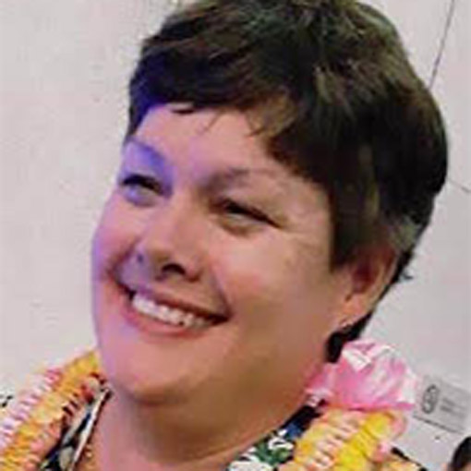

As COVID-19 continues to change our world minute by minute, I think it is very important that advocates have some strong constants in their life.

You, their families and care givers, are their constants, their anchors.

Much like a deployment, where there is constant uncertainty and perpetual change, many advocates are not able to go to their programs and other routine activities that they are used to. Change is scary and unsettling. They are looking to you to know how to navigate their ever-changing world.

If there was ever a time, it is now, for parents and caregivers to breathe deep and pray for guidance on how to remain calm and anchored in this storm.

**1.** I encourage you to keep love in your heart for each other as we all go through this unknown together.

**2.** The virus will pass but the impact of our actions and decisions will remain.

**3.**  Keep our eyes on loving those we are with because the virus will pass.

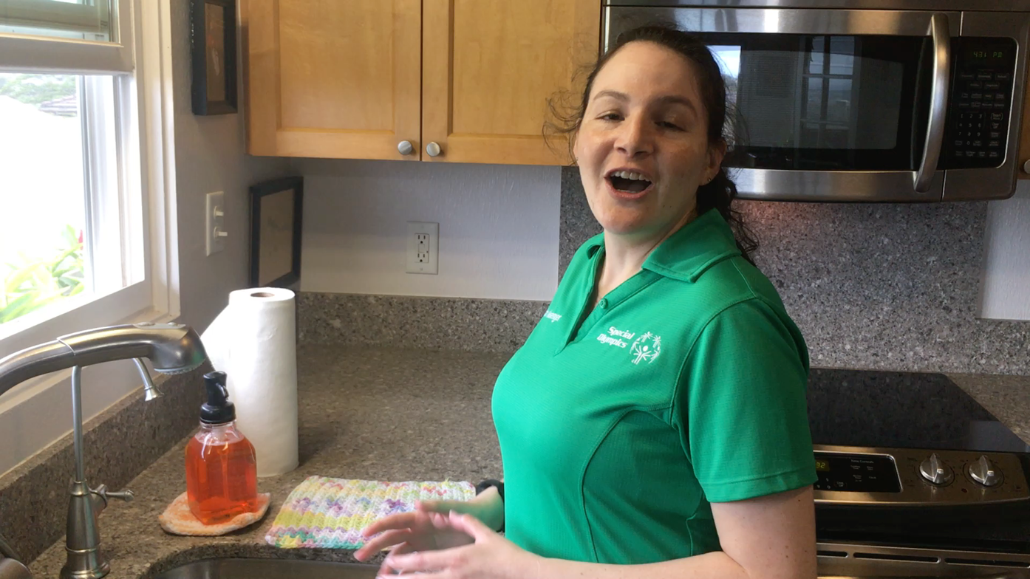

**Renee**

I think with the COVID-19 virus that my work as a Health Messenger with Special Olympics is important. As I share current health and safety information I believe advocates will feel more empowered about what to do during this time of uncertainty. I think that taking time to exercise and focus on the positive will keep us healthy physically and mentally.

Please visit the Special Olympics website and see our washing hands document and watch my Handwashing video

<https://drive.google.com/file/d/1Q1bJZ6fnTSLE4WlE28KHKWcOCDC84Mms/view>

[SOHI Handwashing.MOV](https://drive.google.com/file/d/1l37EnUSRtn_F44tkvqD65wFCWnohllin/view)



 808-772-0294

 [tammy@tammyevrardconsulting.com](mailto:tammy@tammyevrardconsulting.com)

 TammyEvrardConsulting.com

